For x path:

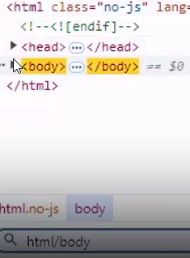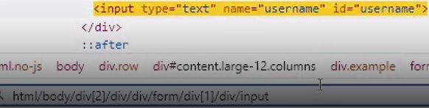

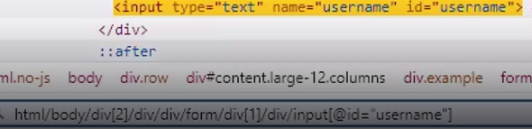

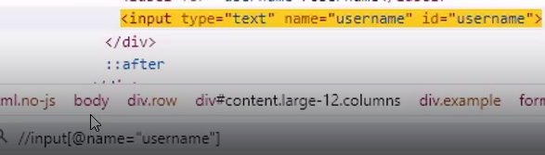

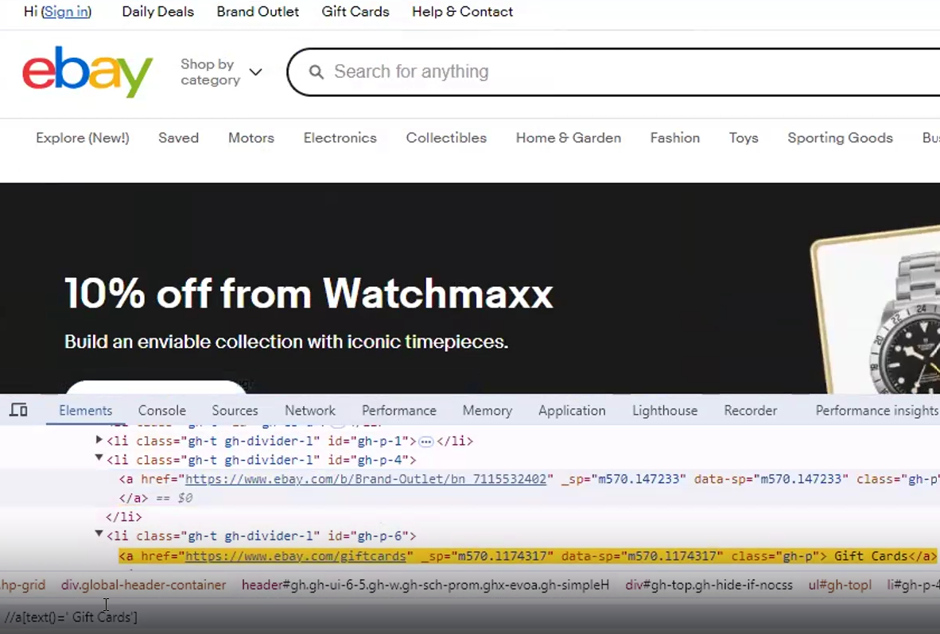



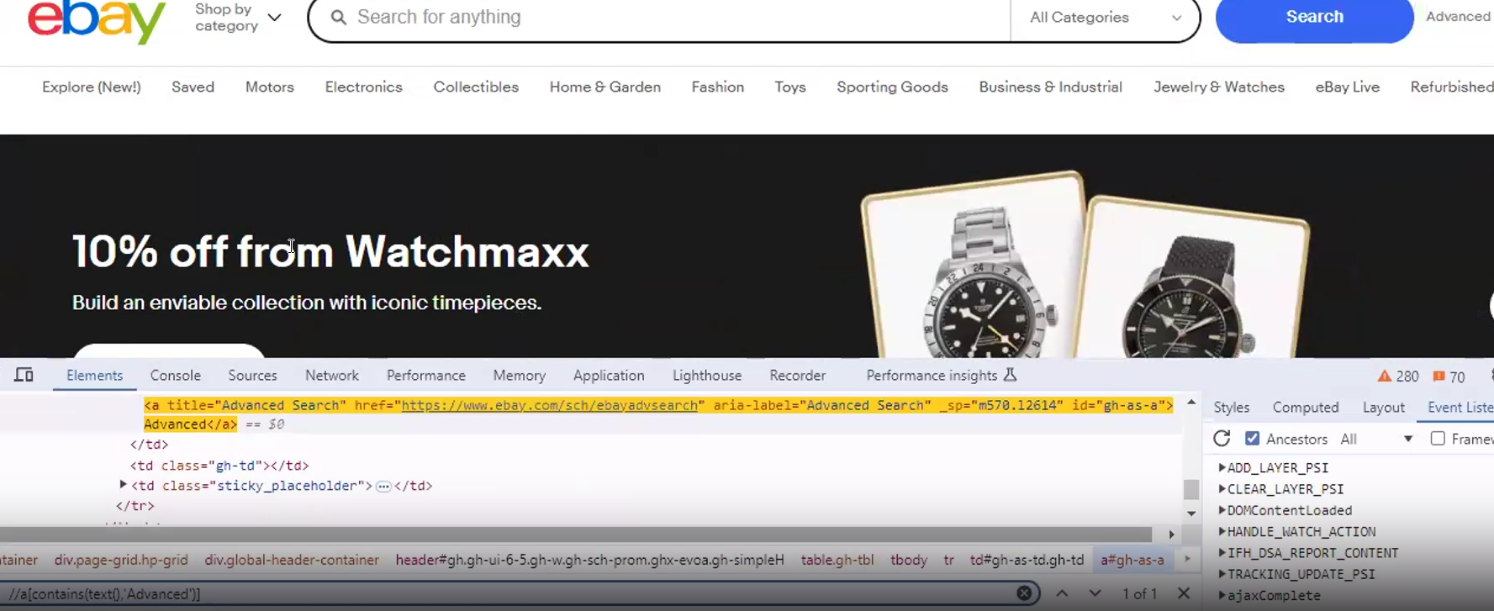

Indexing:

(//a[contains(text(), ‘Saved’)])[1]

(//a[contains(text(), ‘Saved’)])[3]

Inside the basics folder create the v1test.js file its code is as fallows:

///<reference types=”cypress” />

describe(‘v1 tests’, () => {

it(‘Formtest – using CSSselectors’, () => {

cy.visit(‘https://v1.training-support.net/selenium/simple-form’)

cy.get(“#firstname”).type(“Akshay”);

cy.get(“#lastname”).type(“Koulgi”);

cy.get(“#email”).type(“”);

});

});